**Test Cases**

|  |  |  |  |  |
| --- | --- | --- | --- | --- |
| **Test Case** | **Module** | **Features** | **Expected output** | **Observed Output** |
| 1a | Registration | All fields mandatory | Show pop up while registering | Shows pop up while registering |

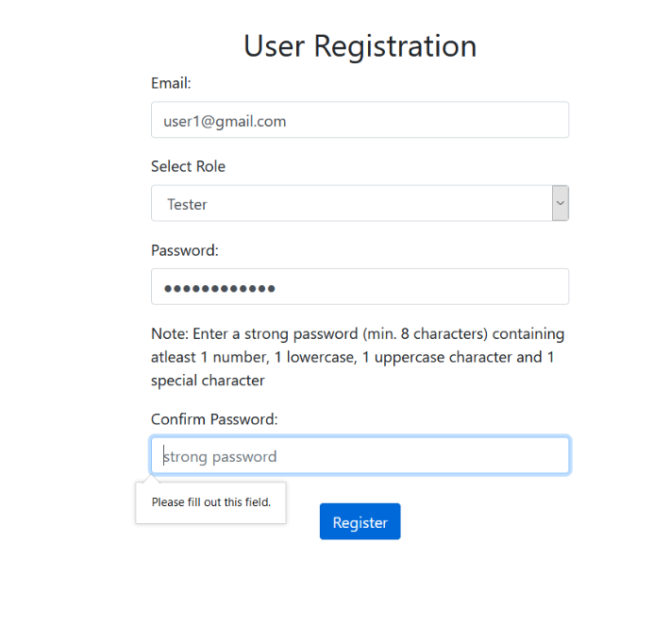

|  |  |  |  |  |
| --- | --- | --- | --- | --- |
| **Test Case** | **Module** | **Features** | **Expected output** | **Observed Output** |
| 1b | The email address should exist and match with the role | All fields mandatory | Shouldn’t add an email that is not present and match with the role | Doesn’t add an email that is not present and match with the role |

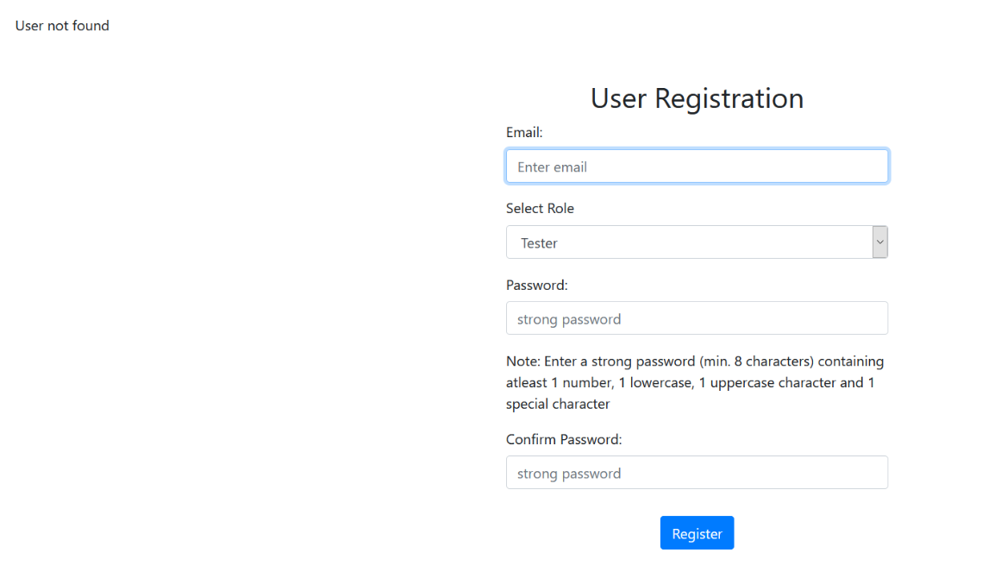

|  |  |  |  |  |
| --- | --- | --- | --- | --- |
| **Test Case** | **Module** | **Features** | **Expected output** | **Observed Output** |
| 1c | Registration | The user should not have already been registered | Should not allow the already existing user to register | Doesn’t allow the already existing user to register |

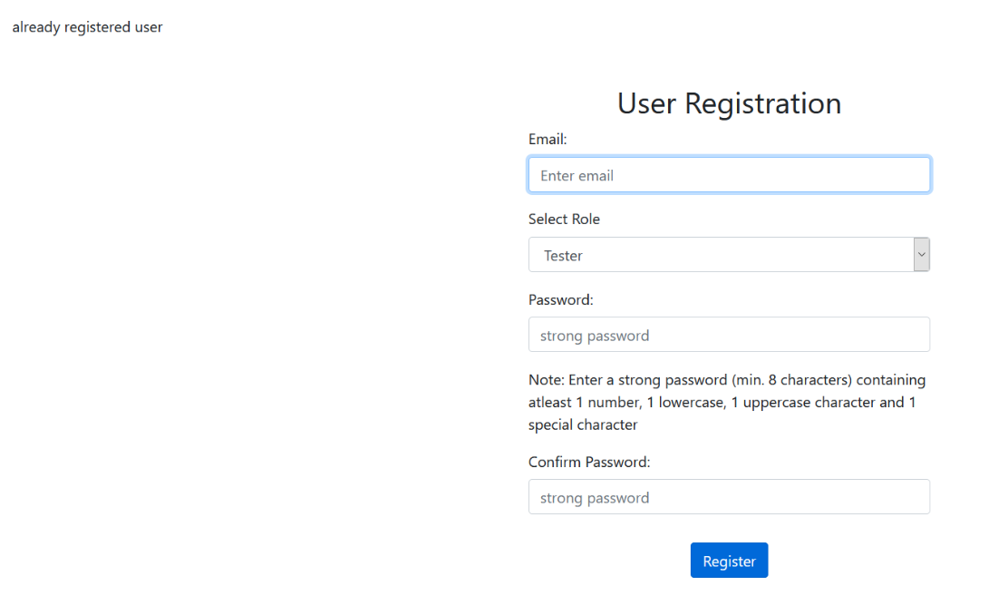

|  |  |  |  |  |
| --- | --- | --- | --- | --- |
| **Test Case** | **Module** | **Features** | **Expected output** | **Observed Output** |
| 2a | Create new project | Start date should be at least 2 days later than the current date | Should not allow to create a project with start date less than 2 days from current date | Doesn’t allow the already existing user to register |

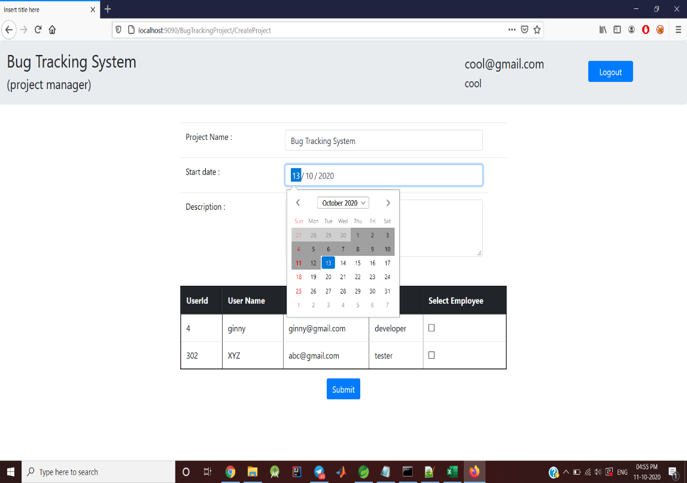

|  |  |  |  |  |
| --- | --- | --- | --- | --- |
| Test Case | Module | Features | Expected output | Observed Output |
| 2b | Create new project | The project should be set to "in progress" | The new project should be set to "in progress" by default | The new project is set to "in progress" by default |

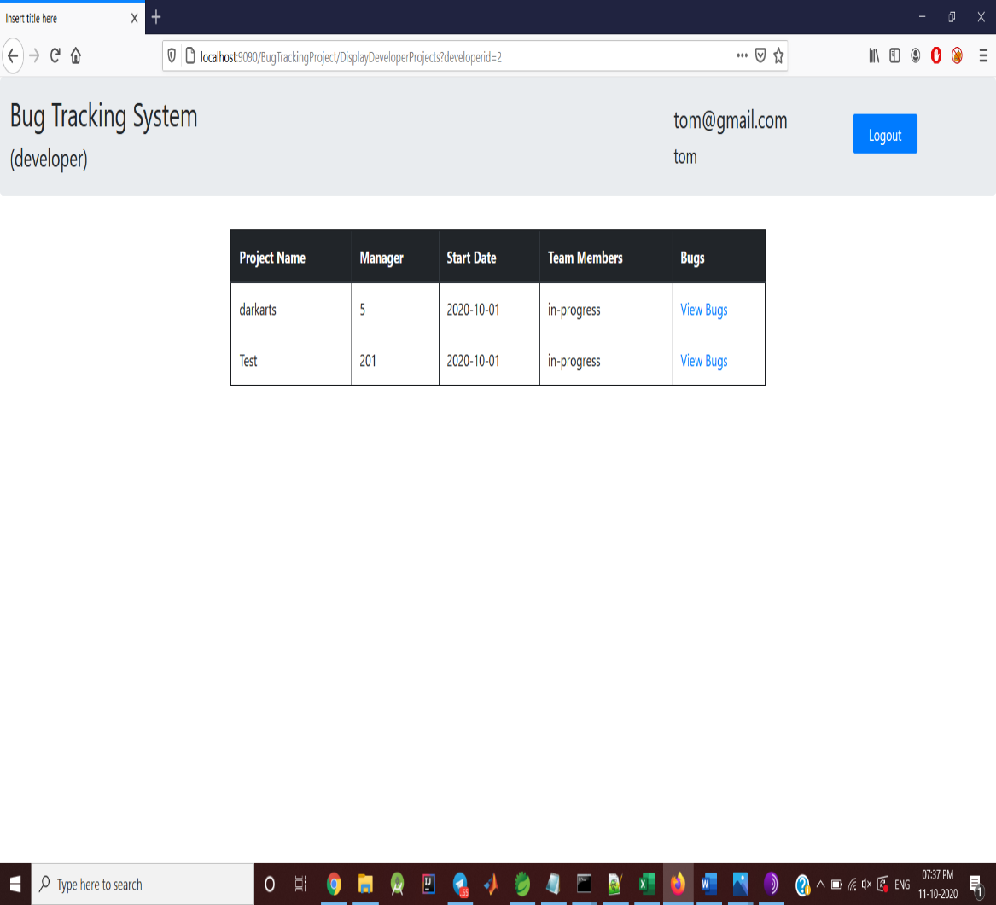

|  |  |  |  |  |
| --- | --- | --- | --- | --- |
| Test Case | Module | Features | Expected output | Observed Output |
| 2c | Create new project | Developers can be assigned to only one project | Any developer can have a maximum of one project | A developer can be assigned to one project only |

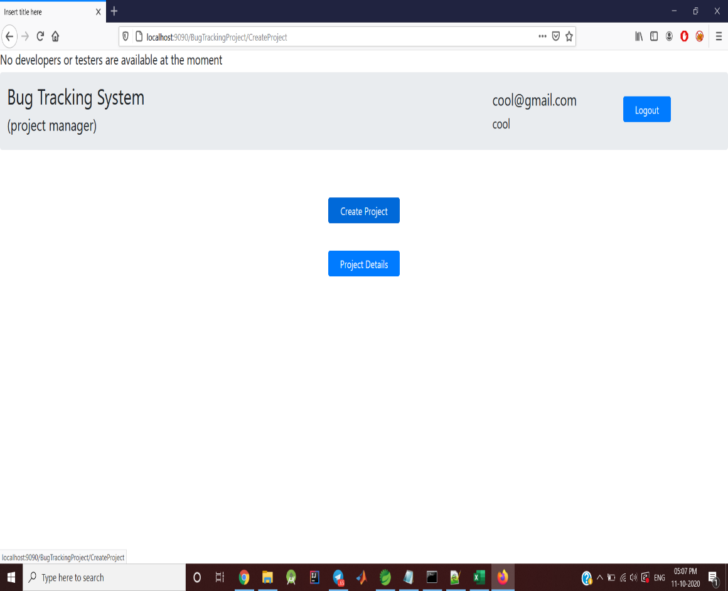

|  |  |  |  |  |
| --- | --- | --- | --- | --- |
| Test Case | Module | Features | Expected output | Observed Output |
| 2d | Create new project | Testers can be assigned to only two projects | Any tester can have a maximum of two projects | A tester can be assigned to two projects only |

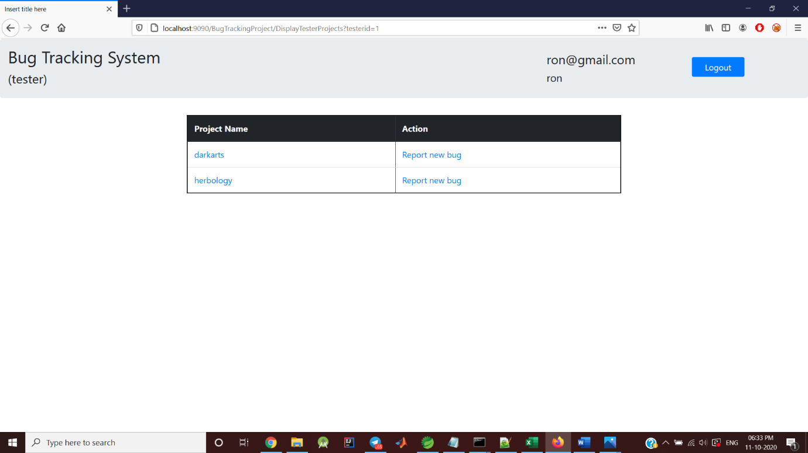

|  |  |  |  |  |
| --- | --- | --- | --- | --- |
| Test Case | Module | Features | Expected output | Observed Output |
| 2e | Create new project | Testers can be assigned to projects only under the same manger | both the projects for the tester should be under the same manager | Tester can be assigned to two projects under the same manager only |

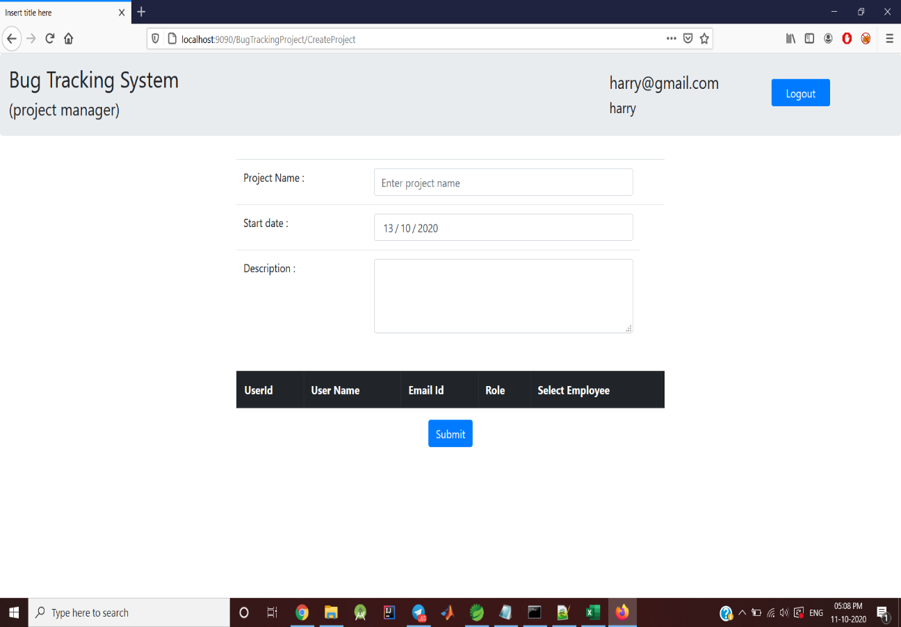

|  |  |  |  |  |
| --- | --- | --- | --- | --- |
| Test Case | Module | Features | Expected output | Observed Output |
| 3 | Login | Handling user not found | If an unregistered user tries to login system should throw an exception | Tester can be assigned to two projects under the same manager only |

